

Gate Access Control System (GACS)

Handover Documentation

1. System Overview & Architecture

1.1 Purpose & Scope
The Gate Access Automated System (GACS) is a platform that integrates real-time computer vision, embedded hardware control, cloud/edge backend services and a multi-tenant user interface to provide secure, automated, and audited entry and exit management for vehicular users and pedestrians within, but not limited to residential estates.

1.2 Objectives
- Automate Vehicle Access: Utilize high-accuracy License Plate Recognition (LPR) to identify authorized vehicles and trigger gate barriers with under 1.5 seconds of total end-to-end latency.
- Multi-Tenant Administration: Allow estate managers to set access policies, view real-time entry logs, manage resident accounts, and manually override gate operations.
- Resident Visitor Management: Enable residents to manage registered vehicles, receive immediate entry notifications, report issues and issue time-bound visitor passes via a mobile application.
- Pedestrian Access Control: Provide a dedicated terminal interface at pedestrian turnstiles/gates utilizing secondary authentication methods (PINs and facial recognition).
- Fault Tolerance & Reliability: Ensure local hardware operates safely during internet connectivity loss with local caching and automated fail-safe mechanisms.

1.3 High-Level System Architecture Diagram
The system architecture is structured across three core operational layers: Client Interfaces, Central Backend & Processing, and Physical Edge Hardware. Figure 1 illustrates the high-level architectural framework, detailing the data flow and integration points between these components. A granular functional breakdown of each layer, along with its specific hardware and software subsystems, is provided in the subsequent sections of this document.
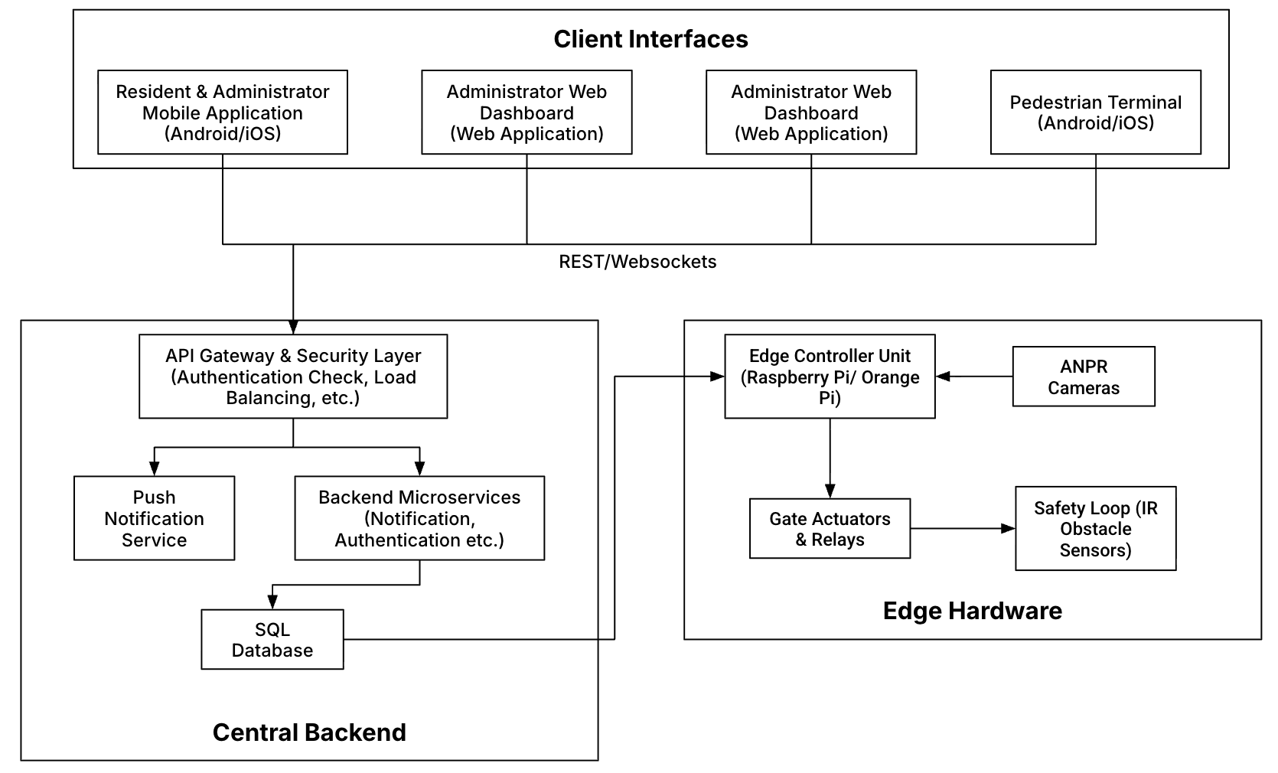

Figure 1. High Level Architecture of the GACS

1.4 Subsystem Interconnections & Responsibilities
Table 1 summarizes the primary subsystems that comprise the system architecture, outlining their core responsibilities and operational roles. These distributed components enable seamless data exchange, low-latency processing, and high system reliability across all entry and exit workflows.

Subsystem | Key Components | Primary Responsibilities
Edge Hardware | LPR Cameras, Microcontroller (Orange Pi/ Raspberry Pi), Relay Modules, Safety Loops, Radio Modules. | Captures license plate frames, processes edge read and write signals from license plate predictions and stored data in the database. Manages physical gate operations by sending wireless control signals via radio modules from the microcontroller to the gate relays.
Backend & Services | API Gateway, Access Logic Engine, LPR Inference Service, Push Notification Server, Relational DB. | Evaluates access rights, stores system state/logs, routes real-time commands via MQTT/WebSockets, sends alerts to mobile clients.
Client Interfaces | Resident App, Estate Admin Dashboard, Pedestrian Frontend | Interface for users to manage vehicles/passes, view live logs, issue remote gate overrides, and grant pedestrian entry.

Table 1. Subsystem Interconnections & Responsibilities

1.5 Data & Signal Flow
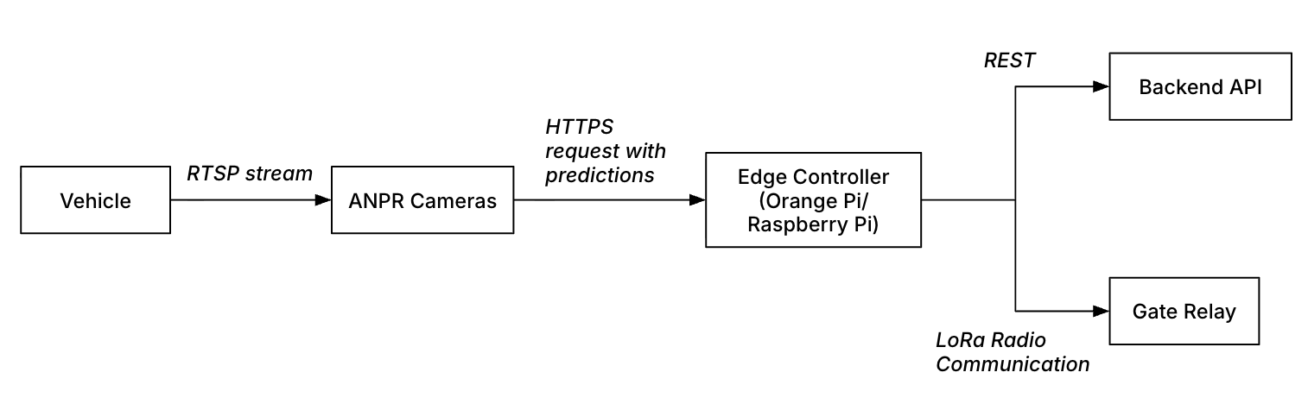
Figure 2. Data Signal Flow

- Trigger Phase: An approaching vehicle enters the ANPR camera’s trigger zone, signaling the ANPR camera to capture a high-resolution imagery frame buffer.
- Plate Extraction Phase: The camera extracts the license plate image crop, runs character recognition (OCR) with the image frame/frames captured.
- Decision Phase: The ANPR camera sends an HTTPS request to the edge controller containing the prediction, other meta data and the frames used for the prediction.
- Validation Logic: The edge controller evaluates before sending a radio frequency to open the gate:
  - Is the plate registered to an active resident or valid visitor pass?
  - Is the estate/gate status active and within allowed access time windows?
  - Is the vehicle already marked inside (anti-passback check)?
- Authorization Request: The Edge Controller sends an authentication payload to the Backend Access Service HTTPS REST endpoint to log an access request into the database.
- Notification Phase: The backend asynchronously dispatches a push notification to the resident associated with the vehicle: "Your vehicle (ABC123GP) entered Main Gate at 09:30 AM."
- Reset Phase: The vehicle passes through, clearing the secondary safety loop / IR beam, signaling the gate controller to close the barrier arm safely.

2. Hardware & Firmware Architecture

2.1 Hardware Bill of Materials (BOM)
The hardware layer of the system consists of three main infrastructures, networking infrastructure for local inter-component communication, the license plate prediction, processing and comparison infrastructure and the gate actuation infrastructure. These infrastructures consist of components that come together to make the hardware sub system function.

Infrastracture | Item / Category | Component Description & Specification | Quantity | Purpose / Function
License Plate Prediction, Processing & Comparison Infrastructure | Single Board Computer (SBC) | Orange Pi 5 / Raspberry Pi 4 (8GB RAM, NVMe/eMMC storage) | 1 per lane | Executes local LPR inference and data formatting from ANPR camera feeds, while validating predictions against registered license plate records obtained from the database. Additionally, it monitors local device health across the network, synchronizes metrics and access logs to the cloud backend, and transmits wireless trigger commands to the gate actuation module.
 | ANPR Cameras | 2MP/4MP, Optical Zoom (2.8–12mm), IR Night Vision, WDR, RTSP Output | 1 per lane | Captures high-frame-rate video feeds directed at vehicle plate height under varying light conditions and broadcasts predictions made from these video feeds in addition to the frames used for the prediction as a data packet.
Networking Infrastructure | Router | 4G+ Cat6 AC1200 Wireless Dual Band Gigabit SIM Router | 1 per setup | The router provides internet connection to the microcontroller, allowing for communication with the database to fetch registered plates, upload access sessions to the cloud etc.
Networking Infrastructure | Network Switch | Managed network switch | 1 per setup depending on the number of ports | The network switch connects multiple lane-level components within the local network, utilizing the central router to assign IP addresses and facilitate low-latency inter-device routing.
Gate Actuation Infrastructure | Edge Microcontroller | Arduino nano | 1 per gate motor | This module receives and decrypts incoming radio frequency (RF) signals from the transmitter module, translating transmitted commands into physical actions such as gate actuation or sending health heartbeats.
Gate Actuation Infrastructure | Radio Communication Module | RYLR998 UART Interface 868/915 MHz LoRa Module | 1 receiver module per gate motor & 1 transmitter per SBC configuration | This module sends and receives encrypted commands using LoRa to communicate over a relatively long distance. It enables wireless communication between the plate prediction, processing and comparison infrastructure, which validates a plate and the gate actuation infrastructure which triggers the gate to open.
Gate Actuation Infrastructure | Relay Modules | Single channel 5V relay module | 1 per gate motor | This module receives trigger signals from the edge microcontroller and energizes the gate motor terminals to initiate physical opening cycles.

Table 2. Hardware Bill of Materials

2.2 Wiring, Electrical Schematics & Physical Pinouts
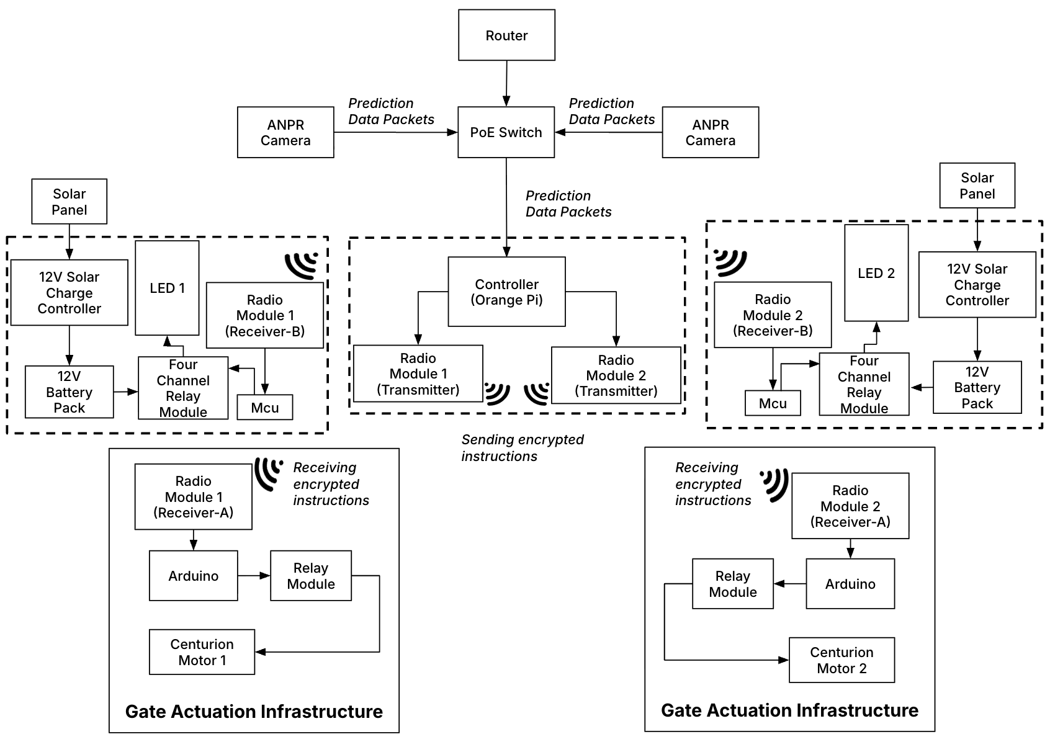

Figure 3. Hardware High-Level System Topology
Figures 3 provide a detailed breakdown of the edge hardware layer referenced in Section 1.4 (Figure 1). Figure 3 illustrates the high-level system topology and inter-component communication flows. The illustrated schematics depict a single-board computer (SBC) setup configured to control two dedicated gate motors, one assigned strictly for entry and the other for exit.

2.3 Firmware & Edge Runtime Architecture
The Single Board Computer (SBC) operates on a lightweight Linux distribution (Ubuntu Server LTS or Armbian), hosting multi-threaded Python and C++ edge daemons managed by systemd services. Figure 5 details the background daemons executing on the edge device, along with the file read and write operations associated with each process. The edge microcontroller (Arduino Nano) runs embedded C++ firmware flashed directly to the board. Figure 5 details the programs running on the edge microcontroller.

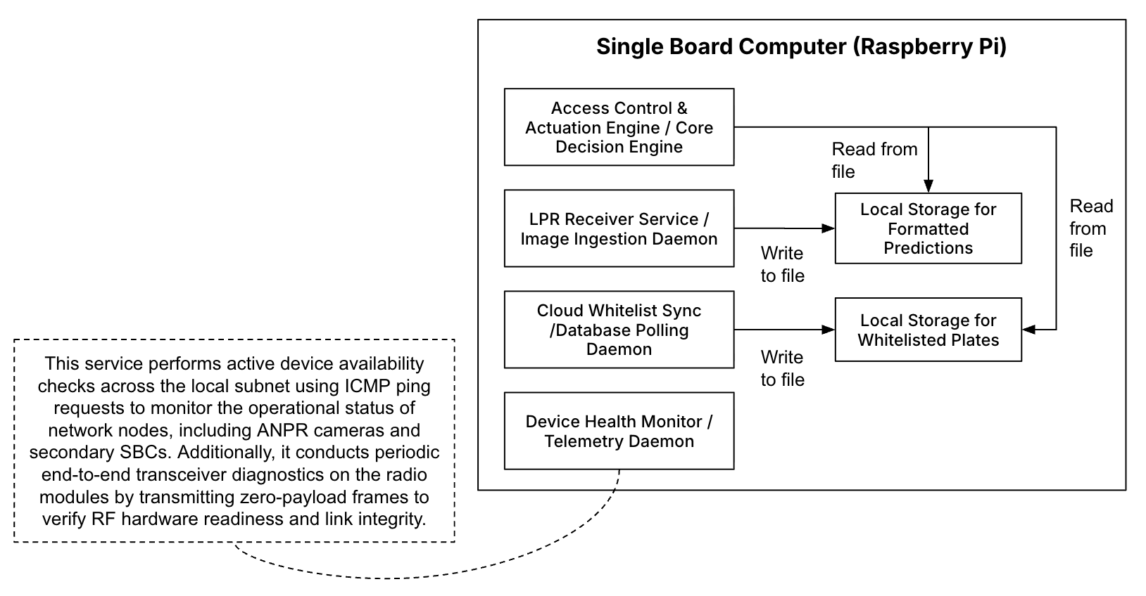
Figure 4. Diagram of Firmware on the Single Board Computer

2.4 Firmware Source Code Repository
The firmware that runs on the Orange Pi device controller is in the GitHub repository https://github.com/Jaymce-git/Firmware_GACS.git. It holds the gate programs: the watcher that reads the daily plate CSV and opens the gate, the Flask server that receives camera 3, the poller that downloads the authorized-plate list, and the recorder and video-upload scripts. Example configuration files are included with the tokens and camera passwords removed. The real configuration, stay on the device and are not in the repository. The README in the repository describes how the programs fit together and how to run them.
Repository: Firmware_GACS (Private)
Framework: Python
Description: The programs in the repository reads the daily plate CSV and opens the gate, as well as notifying users when the action has occurred. It also performs other tasks such as monitoring the devices functionality and uploading access session videos to S3.
Primary Responsibility: Research Engineer

2.5 Summary Table for Firmware & Edge Runtime Architecture
Program Component | Program Name | Type | Key Responsibility
Ingestion | LPR Receiver Service / Image Ingestion Daemon | Background Service | Receives and formats ANPR camera prediction & image frame data packets, formats and saves them into local log files.
Synchronization | Cloud Whitelist Sync /Database Polling Daemon | Background Service | Synchronizes local valid plate lists with cloud database changes (adds/deletions/expirations).
Diagnostics | Device Health Monitor / Telemetry Daemon | Background Service | The service performs active device discovery and availability checks across the local subnet using ICMP ping requests to monitor the operational status of network nodes, including ANPR cameras and secondary Single Board Computers (SBCs). Additionally, it conducts periodic end-to-end transceiver diagnostics on the radio modules by transmitting zero-payload keep-alive frames to verify RF hardware readiness and link integrity.
Core Logic | Access Control & Actuation Engine / Core Decision Engine | Main Engine | Performs plate matching, issues RF open triggers via radio module, and logs access events.

Table 3. Summary Table for Firmware & Edge Runtime Architecture

2.6 Fail-Safe & Resilience Mechanisms
Over the course of development, several fail-safes and architectural strategies were implemented to maximize system availability, fault tolerance, and operational reliability. Key mechanisms include:
- Local Offline Storage & Caching: In the event of a WAN network outage, the edge controller relies on local eMMC/NVMe storage to maintain uninterrupted operations. It caches up to 100,000 entry/exit logs while referencing a locally stored whitelist of authorized vehicles to validate access offline. Once cloud connectivity is re-established, the cached session logs automatically synchronize with the primary SQL database.
- Thermal Throttling Protection: Industrial fan triggers automatically when SBC core temperature exceeds 60°C to prevent CPU throttling during peak sunlight operating conditions.
- Multi-Threaded Execution: To decouple core system operations and eliminate processing bottlenecks, critical tasks, such as network I/O, radio communication to trigger gate, and calls to the database, run on independent threads. This asynchronous execution prevents slow operations from blocking real-time access requests and system responsiveness.
- Watchdog Service: A software watchdog continuously monitors the edge software process. If the main LPR engine freezes or crashes, systemd automatically restarts the service within 3 seconds.

3. Network & Infrastructure Architecture

3.1 Local Area Network (LAN) Configuration & Addressing
The local network infrastructure operates on a dedicated private Class A IPv4 subnet customized with a Class C subnet mask (/24), fully managed by the primary edge router. The network configuration details and assigned static IP addresses for on-site hardware devices are outlined below in Table 4.
- Subnet Mask: 255.255.255.0 (/24)
- IP Address Range: 10.11.12.1 – 10.11.12.254
- Default Gateway: 10.11.12.1 (Edge Router)
- DHCP Scope: Restricted reservation pool for transient technician laptops; static MAC-to-IP bindings used for all core hardware.

Device Hostname | IP Address | Interface | Description / Role
Edge Router | 10.11.12.1 | eth0 | Main local gateway & DHCP/DNS router
PoE Switch | 10.11.12.2 | eth0 | Power-over-Ethernet switch supplying cameras & SBC
Edge Controller | 10.11.12.3 | eth0 | Primary Edge Controller/ Single Board Computer (Orange Pi 5 / Raspberry Pi 5)
Connected Devices | 10.11.12.4 - 10.11.12.5 | eth0 / wlan0 | Laptop connection for troubleshooting and changing configurations.
ANPR Cameras | 10.11.12.6 - 10.11.12.X | eth0 (PoE) | ANPR Cameras at the entry and or exit with RTSP streams.

Table 4. Device Local Network Configurations

Note: The network architecture was configured to support scalable single- or dual-lane gate layouts. Each lane accommodates up to three high-definition ANPR cameras alongside standard edge controllers.

3.2 Non-IP RF Wireless Communication (Sub-865MHz Radio Module)
To trigger the physical gate motors without routing long physical cables or depending on local Wi-Fi reachability, the system uses a dedicated Radio Frequency (RF) Sub-Network. While operating outside the 10.1.2.3.X TCP/IP stack, the radio layer acts as an isolated physical transport medium between the Edge Controller and the Gate Actuation Units. Figure 6 shows the communication between the network module.
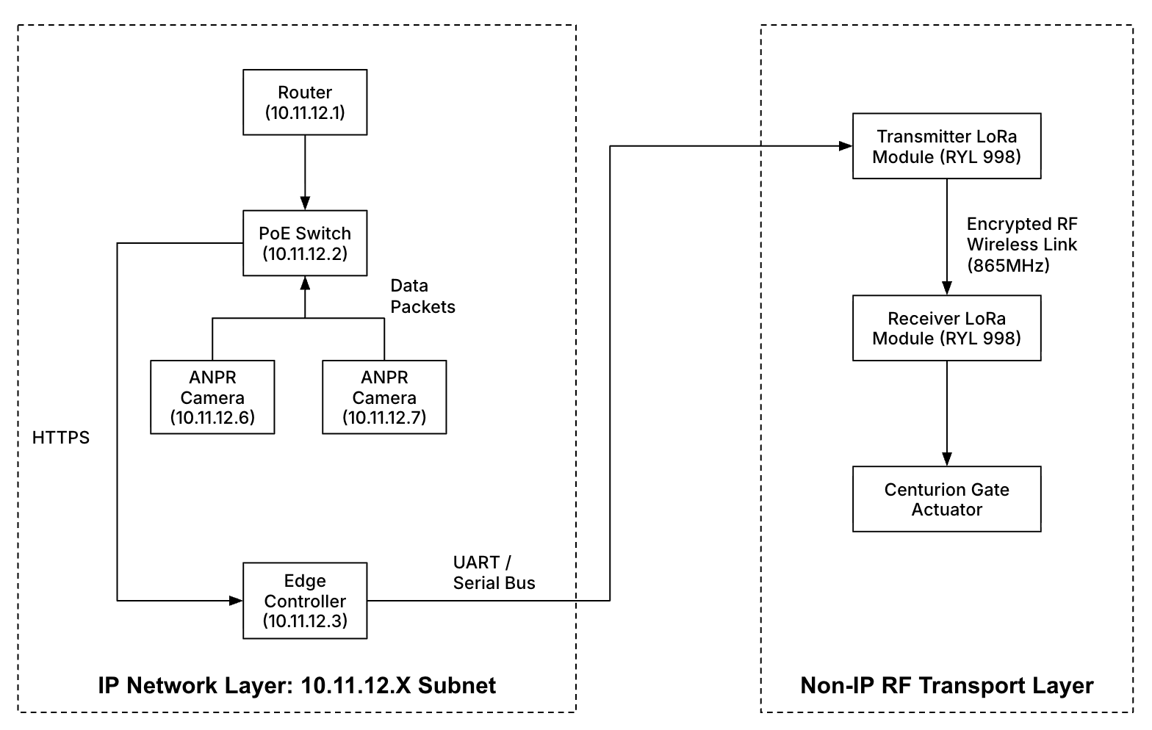
Figure 5. Communication Boundaries Between Network Modules

The system utilizes RF transceiver modules operating at 865 MHz frequency band (RYL998), connected directly to the Orange Pi GPIO header via a UART serial interface. Data is transmitted using a 32-byte encrypted binary payload structure with baud rate of 115200 that includes a Node ID, Command Opcode (such as 0x01 for OPEN or 0x02 for CLOSE), a rolling security token nonce, and a CRC checksum for data integrity. Additionally, the health_monitor_service maintains system reliability by periodically issuing zero-payload RF heartbeats to verify module responsiveness without triggering unintended gate actuation.

3.3 Security Configuration & Device Isolation
To safeguard the physical infrastructure against unauthorized access and network-based threats, the system incorporates strict network segmentation and boundary security mechanisms. Key network security controls include:
- Subnet Isolation: The ANPR edge subnet is isolated from public internet access. Outbound connections are restricted to authorized backend domain endpoints over TLS (Port 443) and MQTT (Port 8883).
- Air-Gapped Actuation Layer: Because gate opening commands run across the non-IP radio link, cyber attacks originating from the local network cannot directly send arbitrary IP commands to actuate gate relays.

4. Backend & Database Architecture
The backend uses Amazon API Gateway and AWS Lambda to process requests from the mobile application and gate controllers, manage access records, and handle gate events. Database storage holds application data, Amazon S3 stores images, CloudWatch supports monitoring, and the messaging service delivers notifications. Figure 6 shows the current backend architecture in use.

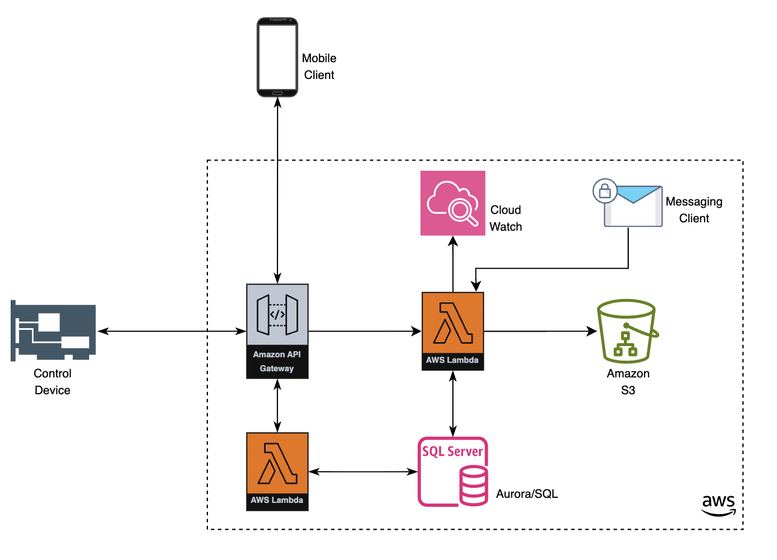
Figure 6. Current Backend Architecture for the Gate Access System
Proposed Backend Enhancements
The following diagram shows the proposed additions to the current architecture. AWS IoT Core provides MQTT communication with gate controllers, and a Device Controller Lambda bridges device messages with backend workflows. This will allow committed access changes, including deletions and permission updates, to be pushed to devices with less polling. Controllers should enforce expiry times locally and synchronize missed changes after reconnecting.
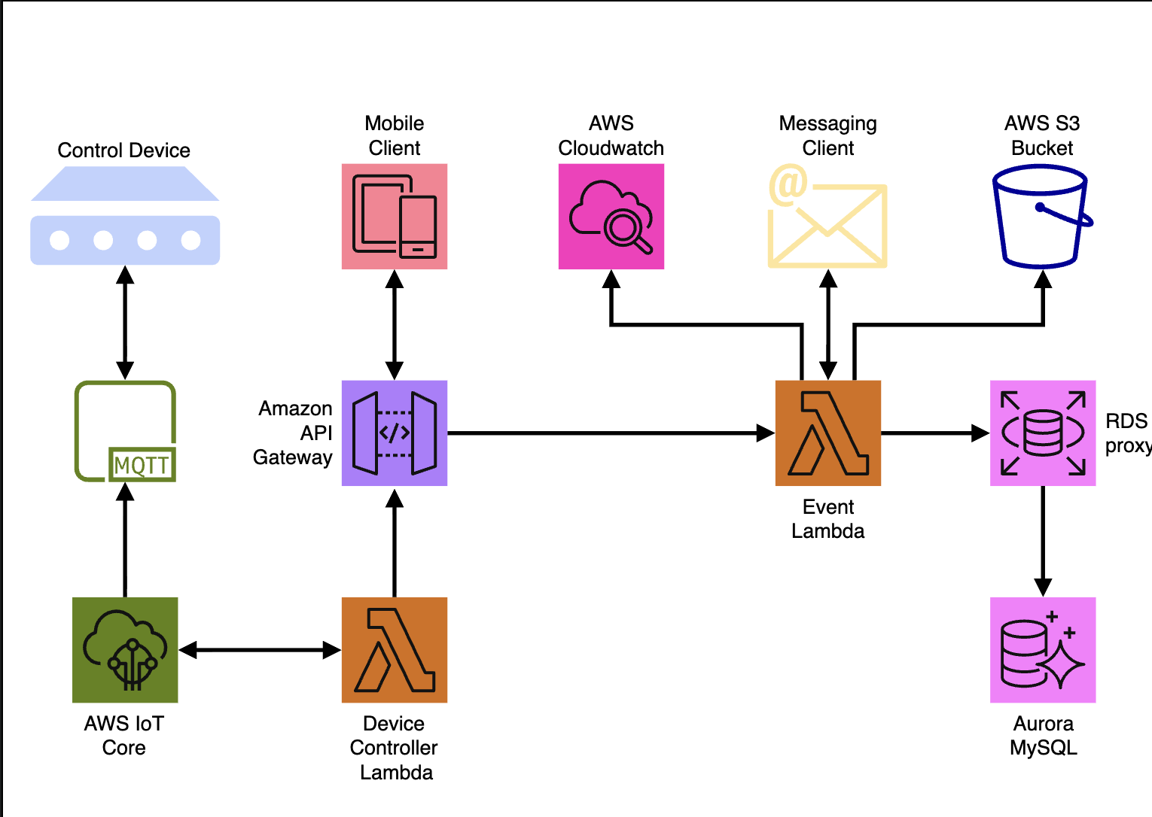
Proposed Backend Architecture for the Gate Access System
RDS Proxy will pool and reuse database connections from concurrent Lambda requests, helping reduce connection pressure on Aurora MySQL. Aurora MySQL will store the central access data; RDS Proxy manages connections rather than resolving conflicting updates. API Gateway, event-processing Lambda functions, S3 image storage, CloudWatch monitoring, and messaging remain part of the design. A transactional outbox and publisher workflow should forward committed database changes to IoT Core; this implementation detail is not shown in the proposed diagram.

The following is the link to the gate access database ERD diagram : Lucidchart

5. Frontend & Client Applications Architecture

5.1 Architecture Overview
The system provides three specialized client interfaces designed to accommodate distinct user roles, access workflows, and hardware environments:
- Resident & Administrator Mobile Application: A cross-platform mobile application developed with Flutter (Dart) for iOS and Android, allowing residents to manage visitor access and view real-time entry logs.
- Estate Administrator Web Dashboard: A web-based management portal that enables security personnel and estate managers to oversee multi-tenant operations, perform manual overrides, and review system audit trails.
- Pedestrian Terminal: A dedicated cross-platform mobile application developed with Flutter (Dart) for iOS and Android, deployed on edge tablet hardware at pedestrian gates, facilitating rapid, low-latency entry validation via PIN codes and facial recognition.
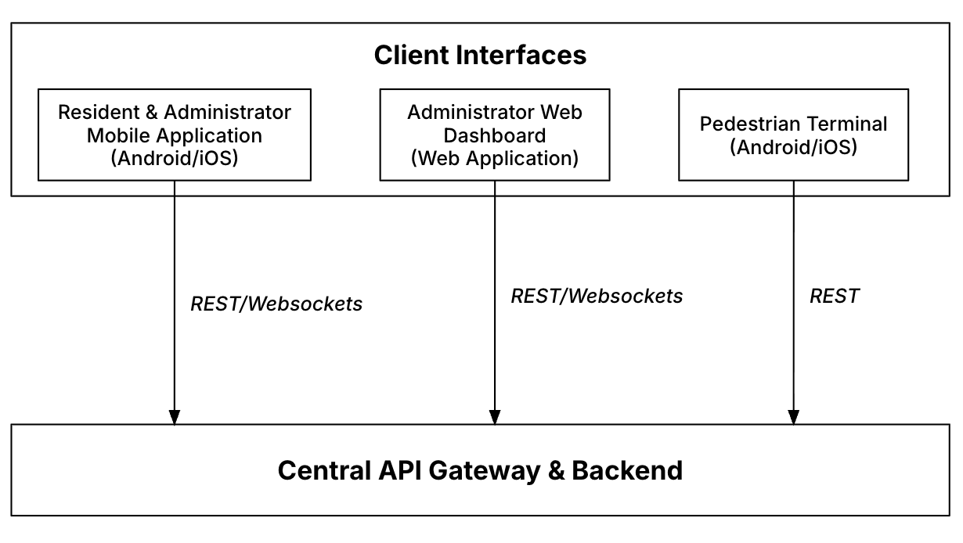
Figure 7. Frontend to Backend Visualization

5.2 Resident & Administrator Mobile Application (Flutter)
Tech Stack & Core Dependencies
- Framework: Cross-platform application built using Flutter (Dart).
- State Management: Architecture structured using Provider / BLoC / Riverpod for predictable state lifecycle management.
- Networking: Integrated via dio / http client packages featuring automated JWT Bearer Token authorization interceptors.
- Real-Time Notifications: Push notification pipeline powered by Firebase Cloud Messaging (FCM) via firebase_messaging.
- Local Storage & Security: Implements flutter_secure_storage for encrypted token persistence alongside shared_preferences for localized user configuration data.

Key Features & Workflows
- Vehicle Registration Management: Residents can view, add, or delete registered license plates linked to their household unit.
- Visitor Pass Generation: Generates temporary, time-bound visitor access passes (with shareable pincodes or pre-registered license plates for visitor vehicles).
- Real-time Entry Alerts: Users receive immediate FCM push notifications whenever a vehicle registered to the household triggers an entry or exit event.

5.3 Estate Administrator Web Dashboard
The Estate Administrator Web Dashboard provides real-time monitoring, estate configuration, access auditing, and manual gate overrides. It is built as a Single Page Application (SPA) using React on the frontend, backed by a Node.js API gateway and real-time messaging layer.

Tech Stack & Core Dependencies

Frontend (React)
- UI Framework & Components: React.js, Material UI (MUI DataGrid for high-frequency logs).
- State Management & Data Fetching: TanStack Query (React Query) for API caching and state management; React Context API for global auth session state.
- HTTP Client: Axios with global JWT request/response interceptors.

Backend Gateway & API (Node.js)
- Runtime & Web Framework: Node.js framework.
- Authentication & Authorization: JSON Web Tokens (JWT) with role-based access control (RBAC: SuperAdmin, EstateManager, SecurityGuard).
- Process Management: PM2 process manager for continuous execution, clustering, and auto-restart capability.

Key Modules & Implementation Details

1. User & Household Management
- Resident Lifecycle Management: Full CRUD interface to activate or deactivate residents.
- Vehicle Whitelist Provisioning: Adding, updating, or deactivating resident vehicles. Any modification triggers an automated background event that updates the central SQL database and dispatches a sync payload down to the Edge SBCs.

2. Live Audit & Access Logs
- High-Frequency Data Grid: Optimized tabular view rendering real-time vehicle entry/exit events received via REST API.
- Log Record Schema Attributes:
  - Timestamp: High-resolution ISO timestamp of the gate event.
  - Recognized Plate Text: Formatted string (e.g., ABC123GP).
  - Match Status Badge: Visual status indicators (ENTRY, EXIT).
  - Gate & Lane Identifier: Specific entry point (e.g., STAFF GATE, MANAGEMENT GATE).

3. System Telemetry & Health Monitoring
- Device Status Dashboard: Graphical cards and indicators displaying live hardware status feeds collected by the backend.
- Monitored Telemetry Metrics:
  - Edge Controller SBC: CPU usage, RAM utilization, core temperature (°C).
  - ANPR Camera Status: Ping reachability (10.1.2.3.20), frame rate stream health.
  - RF Radio Modules: Transceiver heartbeats and communication packet link loss.
  - Power Infrastructure: Battery voltage levels, solar charge controller status, and main AC grid availability.

5.4 Pedestrian Terminal

Technical Design & Operation
- Deployment Target: Mounted Android tablet or dedicated kiosk unit situated at pedestrian gates.
- Input Interfaces: Integrated camera for facial recognition scanning, or physical/virtual PIN keypad.
- Authentication Pipeline:
  - Pedestrian presents a visitor pincode (generated via the resident Flutter app).
  - The terminal performs local validation by firing a low-latency HTTPS check to the backend API.
  - Upon validation, the terminal captures the image of the requester and triggers an onboard relay or sends an actuation command through bluetooth to open the pedestrian turnstile/gate.

5.5 App Deployment & Build Pipelines
Client Application | Target Environment | Build / Artifact Output | Deployment Channel
Resident App (Flutter) | iOS | .ipa bundle | Apple TestFlight
Resident App (Flutter) | Android | .aab / .apk package | Google Play Console / Direct Internal Distribution
Admin Web Dashboard | Web Browser | Static Web Assets (HTML/JS/CSS) | Deployed to research EC2 instance
Pedestrian Terminal | Android/iOS | .apk (Single-App Kiosk Mode) | MDM (Mobile Device Management) / Direct APK Install

Table 5. App Development & Build Pipeline

5.6 Source Code Repositories
The mobile application source code, infrastructure configuration, and deployment scripts are managed and version-controlled across secure Git repositories. All mobile application source code, configuration files, and assets are hosted in the private https://github.com/Jaymce-git/GateAccess_2.0.git repository.
The web application dashboard source code, configuration files, and assets are hosted in another private https://github.com/Jaymce-git/GACS-Dashboard.git repository.

Repository: GateAccess_2.0 (Private)
Framework: Flutter (Dart SDK $≥$ 3.9)
Description: Serves as the unified cross-platform mobile and web client interface for the system. It encapsulates multi-role functionalities including resident vehicle tracking, visitor pass generation, estate admin operations, granular household privilege management, and localized Bluetooth Low Energy (BLE) pedestrian gate opening.
Primary Responsibility: Mobile App / Flutter Developer

Repository: GACS-Dashboard (Private)
Framework:React.js / Node.js
Description: Estate Administrator web dashboard SPA for live access log auditing, system telemetry monitoring, and manual gate overrides.
Primary Responsibility: Frontend Developer

The codebase (GateAccess_2.0 v2.0.0) unifies four distinct user accounts into a single Flutter application. Routing and interface permissions adapt dynamically post-authentication based on the user's role:

User Roles & Home Views
- Estate Administrator (ADMIN): Directs to Admin Home. Manages estate-wide activity, gate status, resident activation/deactivation, access groups, staff, visitor registration, estate events, and system reports.
- Primary Resident (USER_A): Directs to Resident Home. Registers visitors and events, manages household members, permissions, and vehicles, and views activity history.
- Household Member (SUB_USER): Directs to Household Home. Registers visitors and events within assigned privileges, manages personal vehicles, and reviews recent activity.
- Pedestrian (PEDESTRIAN): Directs to Pedestrian Home. Unlocks supported pedestrian gates via Bluetooth Low Energy (BLE) with optional face capture check-in.
Note: Comprehensive documentation detailing the mobile and web application's architectural structure, state management patterns, and full feature set is available in the README.md file located within the root of the private GitHub repository.

6. Operations & Maintenance (O&M)

6.1 Data Connectivity & Bandwidth Operations
The edge network relies on cellular connectivity (via LTE/5G industrial routers) using local telecom provider data plans (e.g., MTN).

Data Allocation & Consumption Guidelines
- Bandwidth Provisioning: 200 GB per 5-month cycle (supporting approximately 100 active users/vehicles and associated access sessions).
- Data Usage Breakdown:
  - Low-Bandwidth Traffic: Syncing registered plate lists, user additions, and JSON telemetry heartbeats.
  - High-Bandwidth Traffic: Asynchronous background uploads of access event video clips and high-resolution plate crop images to the AWS S3 Bucket for remote web dashboard playback.
- Telecom Renewal Schedule: Data top-ups must be scheduled on a 5-month recurring cycle with the local telecom service provider to prevent cloud sync interruptions.

6.2 Automated Storage Management (Edge Controller)
The Orange Pi Edge Controller incorporates automated self-maintenance routines to manage local NVMe/eMMC storage capacity, eliminating the need for manual disk cleanup routines.
- Immediate Purge: Once a video clip or image crop is successfully transferred to the central AWS S3 bucket, the local file is instantly unlinked from storage.
- Threshold-Based Pruning (FIFO): If WAN connectivity drops and uploads queue up, the edge daemon continuously monitors disk partition usage. If storage reaches the maximum high-water threshold (e.g., 85% capacity), the oldest local video files are automatically pruned on a First-In, First-Out (FIFO) basis.
- Performance Impact: This automated strategy prevents disk exhaustion, file system corruption, and CPU compute throttling, ensuring uninterrupted real-time LPR inference.

6.3 Preventative Maintenance Schedule
While edge storage and software execution are self-managing, physical hardware components require periodic inspection to maintain optical accuracy and mechanical reliability.
Frequency | Target Hardware | Action Item | Responsibility
Monthly | ANPR Camera Lens | Clean camera glass with microfiber lens cleaner; check for cobwebs or dust accumulation affecting OCR quality. | Site Maintenance / Security
Bi-Monthly | Telecom Data Plan | Verify data usage balance on the local router SIM card (MTN/Telco dashboard) to ensure adequate data balance for S3 video uploads. | Systems Administrator
Bi-Annually | Enclosures & Relays | Check outdoor IP66 enclosure seals, inspect terminal block screw tightness, clean internal cooling fans, and verify optocoupler relay functioning. | Systems Administrator
Annually | Ground Loops & Gates | Inspect physical loop sensor seals on driveway paving and calibrate gate motor limits/mechanical linkages. | Gate Technician

Table 6. Preventative Maintenance Schedule Table

6.4 Troubleshooting & Diagnostics Matrix
Symptom / Issue | Potential Cause | Diagnostic Check | Resolution Check
Gate does not open for authorized plate | RF transmitter out of range or unpowered MCU. | Check health monitor service logs inside the dashboard. | Verify radio receiver power; manually trigger RF module via test command; re-align antennas.
S3 video recordings not appearing on Dashboard | Depleted telecom data bundle or cellular outage. | Ping router external IP; check cellular signal strength and data balance. | Top up local SIM card data package (MTN); restart cellular router if connection is frozen.
LPR recognition failure at night | Camera IR illuminator dirt or improper shutter setting. | Inspect night live feed for frame blurring or over-exposure on reflective plates. | Clean camera lens; adjust camera shutter speed to 1/1000s and lock WDR settings.
Edge Controller unresponsive | Thermal overload or power fluctuation | Check CPU temperature via SSH (vcgencmd measure_temp or sensors). | Verify enclosure cooling fan operation; ensure 12V-to-5V DC converter is delivering stable current.

Table 7. Troubleshooting & Diagnostics Table

7. System Improvements & Future Roadmap

7.1 Security Roadmap: AWS Credential Management & S3 Isolation
Currently, the system stores static AWS S3 bucket access credentials in a local .env file on the edge controller (Raspberry Pi / Orange Pi). To eliminate physical credential exposure risks and align with enterprise security standards, the credential architecture can evolve across three maturity phases:
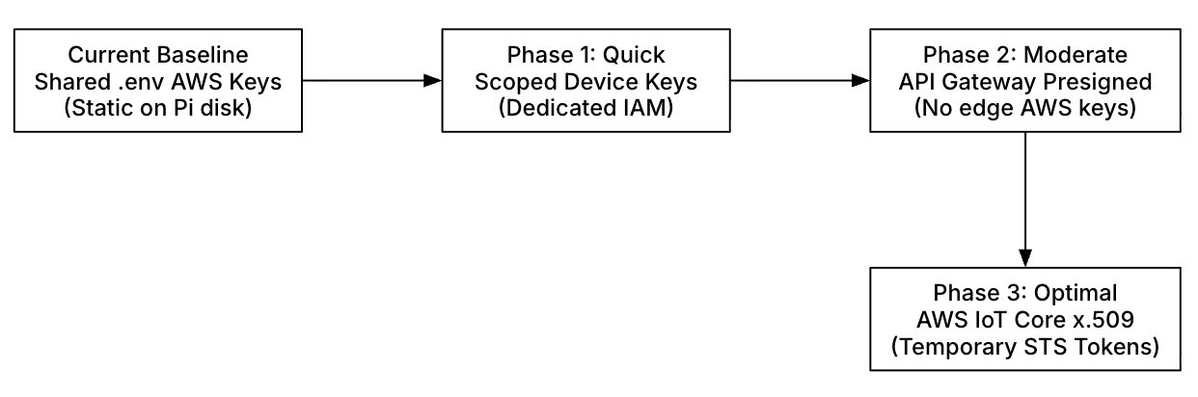
Figure 8. S3 Credential Evolution Pathway

Current Baseline (As-Is System)
- Implementation: Static AWS IAM Access Key ID and Secret Access Key stored locally in a .env file on the edge controller disk.
- Risk: If an edge device (Raspberry Pi) is physically tampered with, compromised, or stolen from an outdoor gate cabinet, the static credentials could be extracted and used to access system S3 resources.

Phase 1: Dedicated Scoped IAM Credentials (Immediate Improvement)
- Strategy: Provision unique, static AWS IAM access keys for each individual deployed edge device rather than using a shared credential set.
- Security Model: Apply strict Principle of Least Privilege (PoLP) IAM policies restricted exclusively to s3:PutObject permissions for the device’s designated S3 bucket path (e.g., arn:aws:s3:::gacs-recordings/estate_id/device_id/*).
- Benefits: Fast to implement; revoking one compromised device’s .env file does not impact other gate lanes across the estate.

Phase 2: S3 Presigned URLs via API Gateway (Intermediate Solution)
- Strategy: Remove all AWS credentials from the edge controller entirely and delegate upload authorization to the Central Backend API Gateway.
- Execution Flow:
  - The Edge SBC sends an HTTP POST request with event metadata (event ID, timestamp, file size) to the Node.js API Gateway.
  - The API Gateway validates the device request and generates a temporary, short-lived S3 Presigned Upload URL (valid for 5 minutes).
  - The Edge SBC uploads the video/image clip directly to AWS S3 using the presigned URL.
- Benefits: Complete removal of AWS IAM credentials from the Raspberry Pi disk.

Phase 3: AWS IoT Core Credential Provider (Target Production Solution)
- Strategy: Leverage the AWS IoT Core credential provider to exchange X.509 device certificates for short-lived, temporary AWS IAM session tokens (STS) on demand.
- Execution Flow:
  - Each Edge SBC is provisioned with a unique X.509 digital certificate and private key stored in secure hardware storage or encrypted keyring.
  - The edge device authenticates to AWS IoT Core over mutual TLS (mTLS).
  - AWS IoT Core issues temporary AWS IAM session credentials valid for short durations (e.g., 1 hour).
- Benefits: Delivers automated, enterprise-grade credential rotation, eliminates long-lived credentials on edge hardware, and enables instant device-level certificate revocation.

7.2 Real-Time Event-Driven Whitelist Synchronization
The current polling mechanism (where the Edge SBC periodically queries the central database for vehicle additions or removals) can be upgraded to an event-driven publish/subscribe architecture.

Proposed MQTT / WebSocket Push Strategy
- Architecture: Establish persistent, bi-directional MQTT or WebSocket connections between the Node.js Backend Gateway and Edge Controllers.
- Execution Flow:
  - An administrator or resident adds, updates, or deletes a registered vehicle plate via the React Web Dashboard or Flutter Mobile App.
  - The backend immediately publishes an encrypted update payload to the device's dedicated MQTT topic (e.g., gacs/estate_01/gate_north/whitelist_update).
  - The Edge SBC whitelist_sync_daemon receives the push event in real time and instantly modifies the local SQLite database/file cache.
- Benefits: Reduces WAN network bandwidth, lowers database query load, and ensures instant revocation of access rights across all gate lanes.

